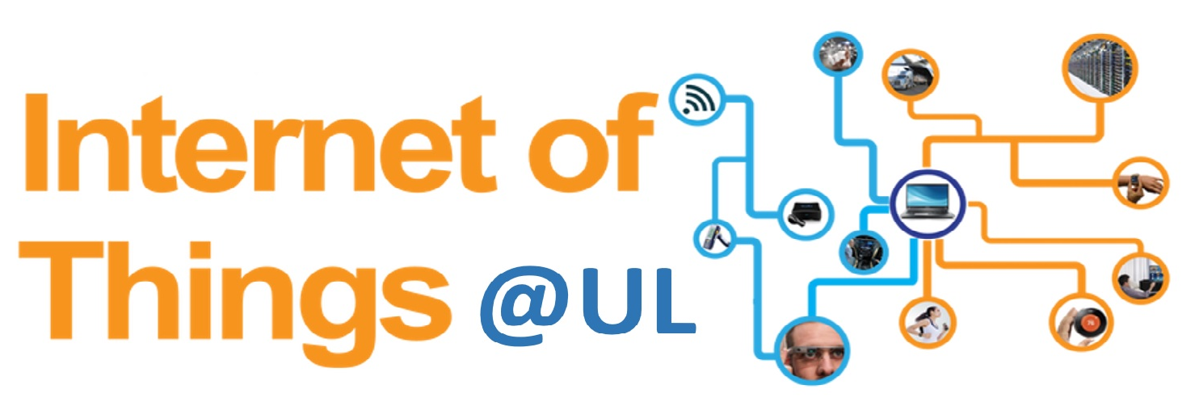

IoT Summer School

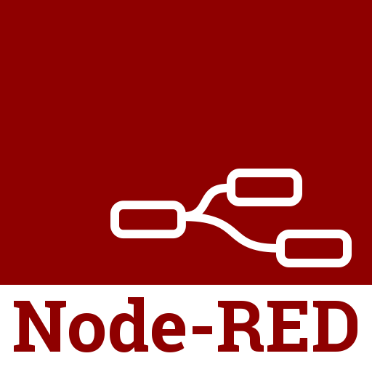

Lab

Table of Contents
1 About Node-RED 3
2 Background Knowledge 4
2.1 MQTT 4
2.3 JSON 5
2.4 Cloudant 6
2.5 Node-RED Messages 7
2.5.1 Payload 7
3 What are we trying to do? 8
3.1 Learning outcomes 8
3.2 Topic structure 8

1 IBM Watson Platform
IBM Watson IoT Platform can help you get a quick start on your next Internet of Things project. It is a fully managed, cloud-hosted service designed to make it simple to derive value from your Internet of Things devices. It provides capabilities such as device registration, connectivity, control, rapid visualization and storage of Internet of Things data.
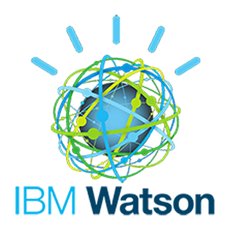
Figure 29
By combining IoT data with cognitive computing, businesses can extract valuable insights to improve virtually every aspect of their operations and enable innovative, new business models.

Node-RED
Node-RED is a tool for wiring together the Internet of Things in new and interesting ways, including hardware devices, APIs, and online services. It is built on top of Node.js and takes advantage of the huge node module ecosystem to provide a tool that is capable of integrating many different systems. Its lightweight nature makes it ideal to run at the edge of the network.[27]
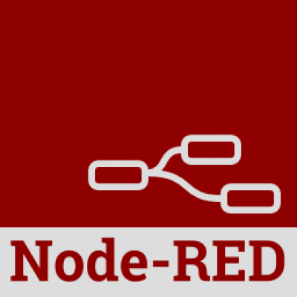
Figure 30
Before going into detail about Node-RED , please give a quick read through the next section of this lab sheet “Background knowledge”. You can safely complete this lab without reading this section but it is advised you do so.

Bluemix (Platform as a Service) and Internet of Things

Bluemix is a fully managed, cloud-hosted service designed to simplify and derive value from your IoT devices. Companies are using Watson Internet of Things to transform their business from the inside out. https://www.ibm.com/cloud-computing/bluemix/internet-of-things
Bluemix is an implementation of IBM's Open Cloud Architecture based on Cloud Foundry, an open source Platform as a Service (PaaS). Bluemix delivers enterprise-level services that can easily integrate with your cloud applications without you needing to know how to install or configure them.
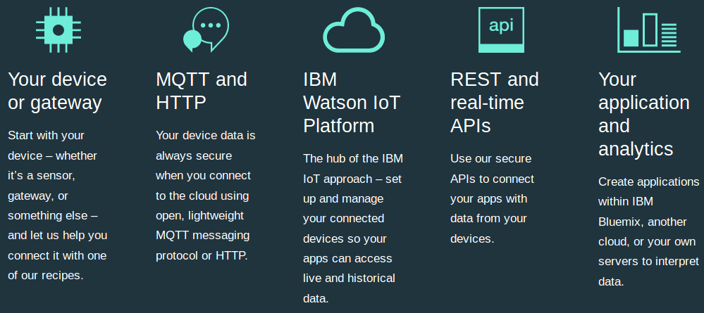

2 Background Knowledge

2.1 Extract Transform Load
The three words in Extract Transform Load each describe a process in the moving of data from its source to a formal data storage system (most often a data warehouse).
- Extract—The extraction process is the first phase of ETL, in which data is collected from one or more data sources and held in temporary storage where the subsequent two phases can be executed. During extraction, validation rules are applied to test whether data has expected values essential to the data warehouse. Data that fails the validation is rejected and further processed to discover why it failed validation and remediate if possible.
- Transform—In the transformation phase, the data is processed to make values and structure consistent across all data. Typical transformations include things like date formatting, resorting rows or columns of data, joining data from two values into one, or, conversely, splitting data from one value into two. The goal of transformation is to make all the data conform to a uniform schema.
- Load—The load phase moves the transformed data into the permanent, target database. Once loaded, the ETL process is complete, although in many organizations ETL is performed regularly in order to keep the data warehouse updated with the latest data.

Why do you need ETL?
ETL takes data that is heterogeneous and makes it homogeneous. Without ETL it would be impossible to programmatically analyze heterogeneous data and derive business intelligence from it.

What is the difference between heterogeneous and homogeneous?
A DDBMS may be classified as homogeneous or heterogeneous. In a homogeneous system, all sites use the same DBMS product. In a heterogeneous system, sites may run different DBMS products, which need not be based on the same underlying data model, and so the system may be composed of relational, network, hierarchical and object-oriented DBMSs.
Homogeneous systems are much easier to design and manage. This approach provides incremental growth, making the addition of a new site to the DDBMS easy, and allows increased performance by exploiting the parallel processing capability of multiple sites.

2.2 Cloudant
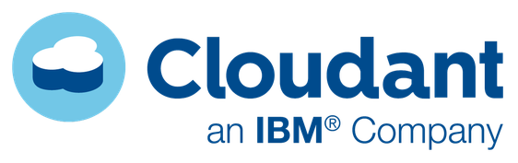
Cloudant is an IBM software product, which is primarily delivered as a cloud-based service. Cloudant is a non-relational, distributed database service of the same name. Cloudant is based on the Apache-backed CouchDB project and the open source BigCouch project.
Cloudant's service provides integrated data management, search, and analytics engine designed for web applications. Cloudant scales databases on the CouchDB framework and provides hosting, administrative tools, analytics and commercial support for CouchDB and BigCouch.[1] Cloudant's distributed CouchDB service is used the same way as standalone CouchDB, with the added advantage of data being redundantly distributed over multiple machines.

Cloudant Geospatial
Cloudant Geospatial combines the advanced geospatial queries of a Geographic Information System (GIS) with the flexibility and scalability of Cloudant’s database-as-a-service (DBaaS) capabilities.
Cloudant Geo:
- Enables web and mobile developers to enhance their applications using geospatial operations that go beyond simple bounding boxes.
- Integrates with existing GIS applications, so that they can scale to accommodate different data sizes, concurrent users, and multiple locations.
- Provides a NoSQL capability for GIS applications, so that large streams of data can be acquired from devices, sensors, and satellites. This data can then be stored, processed, and syndicated across other web applications.

Data flexibility: JSON data store
The majority of requests and responses to and from Cloudant use the JavaScript Object Notation (JSON) for formatting the content and structure of the data and responses.
JSON is used because it is the simplest and easiest solution for working with data using a web browser. This is because JSON structures can be evaluated and used as JavaScript objects within the web browser environment. JSON also integrates with the server-side JavaScript used within Cloudant. https://docs.cloudant.com/json.html
Cloudant’s RESTful API makes every document in your database accessible as JSON. It is also compatible with Apache CouchDB™, enabling you to access an abundance of language libraries and tools.
Schema flexibility makes Cloudant an excellent fit for multi-structured data, unstructured data and fast-changing data models. https://www.ibm.com/analytics/us/en/technology/cloud-data-services/cloudant/

2.3 JSON
JSON, or JavaScript Object Notation, is a minimal, readable format for structuring data. It is used primarily to transmit data between a server and web application.

Keys and Values
The two primary parts that make up JSON are keys and values. Together they make a key/value pair.
- Key: A key is always a string enclosed in quotation marks.
- Value: A value can be a string, number, boolean expression, array, or object.
- Key/Value Pair: A key value pair follows a specific syntax, with the key followed by a colon followed by the value. Key/value pairs are comma separated.
Let's take one line from a JSON sample and identify each part of the code.
"foo" : "bar"
This example is a key/value pair. The key is "foo" and the value is "bar".

Arrays
Almost every blog has categories and tags. In this example we've added a categories key, but the value might look unfamiliar. Since each post in a blog can have more than one category, an array of multiple strings is returned.
"foo" : {
"bar" : "Hello",
"baz" : [ "quuz", "norf" ]
}

Objects
An object is indicated by curly brackets. Everything inside of the curly brackets is part of the object. We already learned a value can be an object. So that means "foo" and the corresponding object are a key/value pair.
"foo" : {
"bar" : "Hello"
}
The key/value pair "bar" : "Hello" is nested inside the key/value pair "foo" : { ... }. That's an example of a hierarchy in JSON data. https://developers.squarespace.com/what-is-json/

3 Node-RED
Node-RED is a tool for wiring together the Internet of Things in new and interesting ways, including hardware devices, APIs, and online services. It is built on top of Node.js and takes advantage of the huge node module ecosystem to provide a tool that is capable of integrating many different systems. Its lightweight nature makes it ideal to run at the edge of the network.[27]
Figure 30

2.5.1 Nodes

mqtt in node
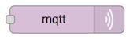
MQTT input node. Connects to a broker and subscribes to the specified topic. The topic may contain MQTT wildcards.
Outputs an object called msg containing
msg.topic,
msg.payload,
msg.qos
msg.retain.
msg.payload is usually a string, but can also be a binary buffer.

mqtt out node
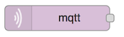
Connects to a MQTT broker and publishes msg.payload either to the msg.topic or to the topic specified in the edit window. The value in the edit window has precedence.
Likewise QoS and/or retain values in the edit panel will overwrite any msg.qos and msg.retain properties. If nothing is set they default to 0 and false respectively.
If msg.payload contains an object it will be stringified before being sent.

2.5.2 Flows

2.5.2 Messages

Node-RED contains the following Watson IoT nodes that helps you to connect your devices, gateways and applications to Watson IoT Platform and create IoT solutions quickly.
- Watson IoT Node – A pair of nodes for connecting your device or gateway to the IBM Watson Internet of Things Platform. A device or gateway can use these nodes to send events and receive commands from the application.[27]
- IBM IoT App Node – A pair of nodes for connecting your application to Watson IoT Platform. An application can use these nodes to receive device events and send commands back to the device.[27]

MQTT

2.x.1 About

2.x.2

2.x.3 Qos
QoS is a major feature of MQTT, it makes communication in unreliable networks a lot easier because the protocol handles retransmission and guarantees the delivery of the message, regardless how unreliable the underlying transport is. Also it empowers a client to choose the QoS level depending on its network reliability and application logic.

QoS 0 – at most once
The minimal level is zero and it guarantees a best effort delivery. A message won’t be acknowledged by the receiver or stored and redelivered by the sender. This is often called “fire and forget” and provides the same guarantee as the underlying TCP protocol.

QoS 1 – at least once
When using QoS level 1, it is guaranteed that a message will be delivered at least once to the receiver. But the message can also be delivered more than once.
The sender will store the message until it gets an acknowledgement in form of a PUBACK command message from the receiver.
The association of PUBLISH and PUBACK is done by comparing the packet identifier in each packet. If the PUBACK isn’t received in a reasonable amount of time the sender will resend the PUBLISH message. If a receiver gets a message with QoS 1, it can process it immediately, for example sending it to all subscribing clients in case of a broker and then replying with the PUBACK.
The duplicate (DUP) flag, which is set in the case a PUBLISH is redelivered, is only for internal purposes and won’t be processed by broker or client in the case of QoS 1. The receiver will send a PUBACK regardless of the DUP flag.

QoS 2 - Exactly once
The highest QoS is 2, it guarantees that each message is received only once by the counterpart. It is the safest and also the slowest quality of service level. The guarantee is provided by two flows there and back between sender and receiver.
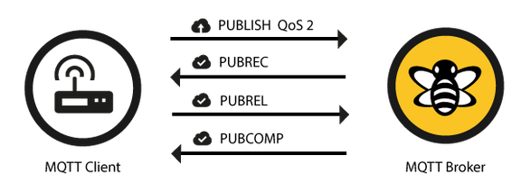

3 What are we trying to do?
In part 1 of this lab group members will send messages to each other using mqtt nodes and topics.
In part 2 you will create a new flow and explore Cloudant and Watson Analytics nodes.

3.1 Learning outcomes
On successful completion of this lab you will have learned about
- MQTT pub/sub protocol and QoS
- Controlling data through MQTT topics using Node-RED flows
- Sensor readings represented in JSON format
- How messages flow through nodes
- Debug and mqtt nodes
- Cloudant database nodes
- Watson Analytics nodes

3.2 Topic structure
→ iot-summer-school
→ group-1-iotp
→ Ann
→ Bob
→ Joe
→ group-2-iotp
→ Jim
→ …

4 Node-RED Lab part 1: Getting started

Step 1 : Sign up for 30 day free trial
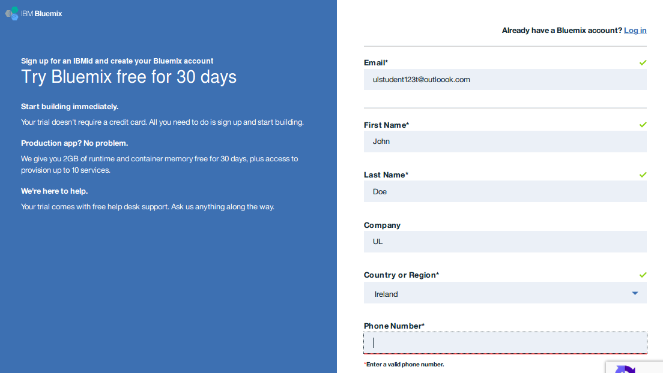

Step 2: Click on link in the email to complete registration
Click on “Log in”

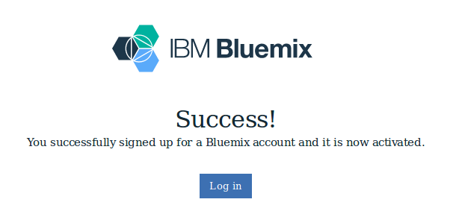

Step 3: Login
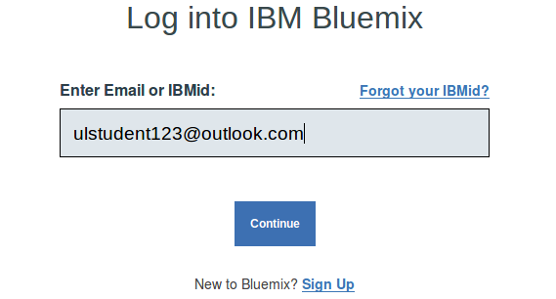

Step 4: Create organization

Does it matter if I pick US South over the others?
For the purpose of this lab it does not matter, however when dealing with OpenWhisk actions and Kubernetes clusters you will need to have your organization set in US South.
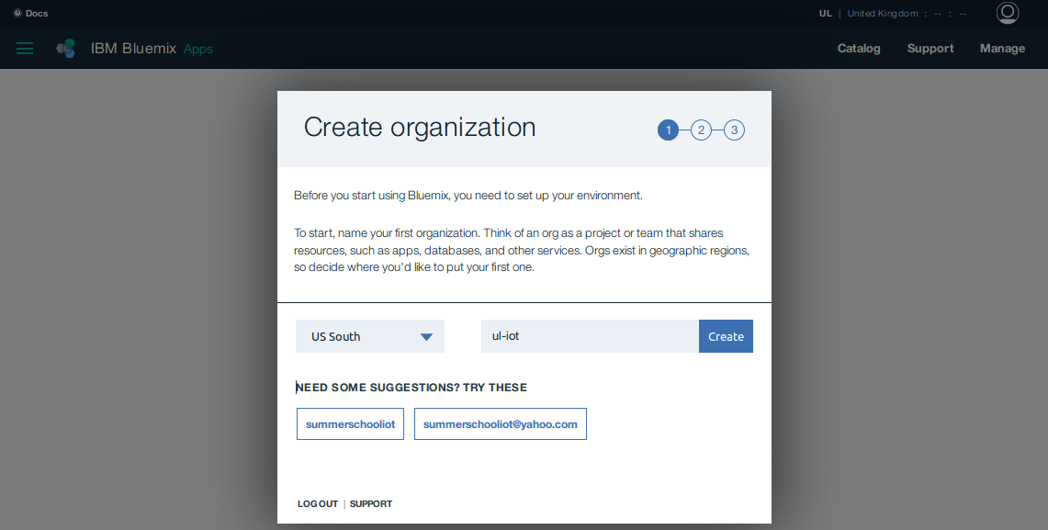

Step 5: Create space
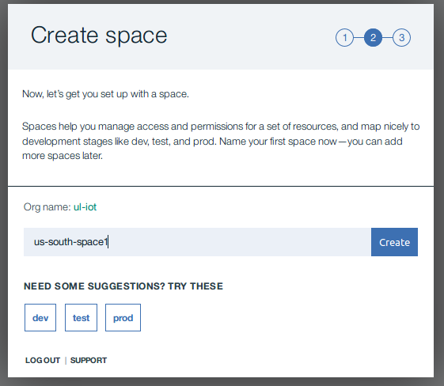

Step 6: Click “I’m Ready”

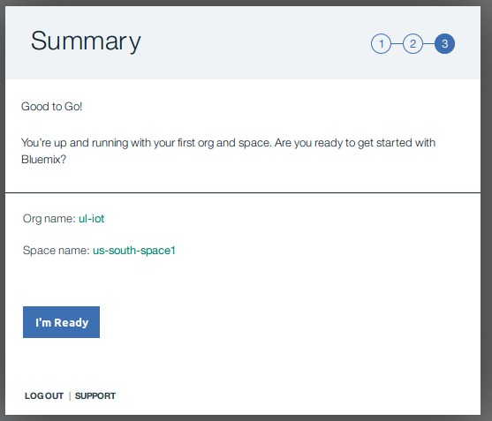

Step 7: Click on “Create app”
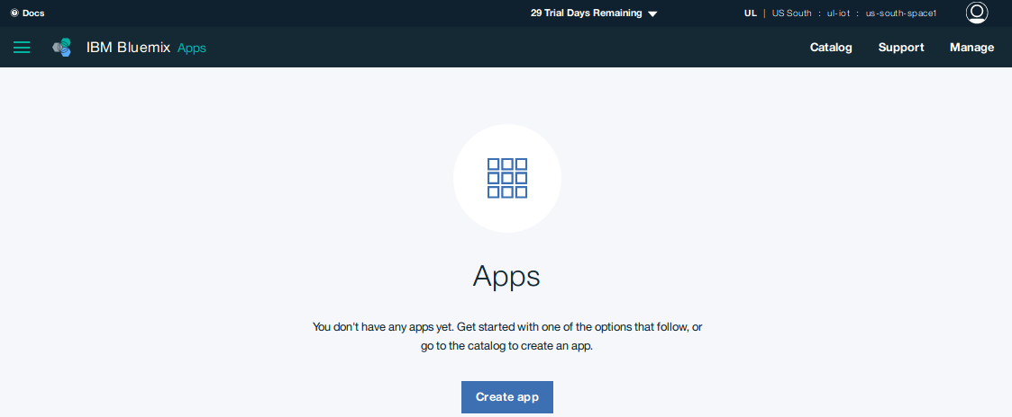

Step 8: Select “Internet of Things Platform Starter”
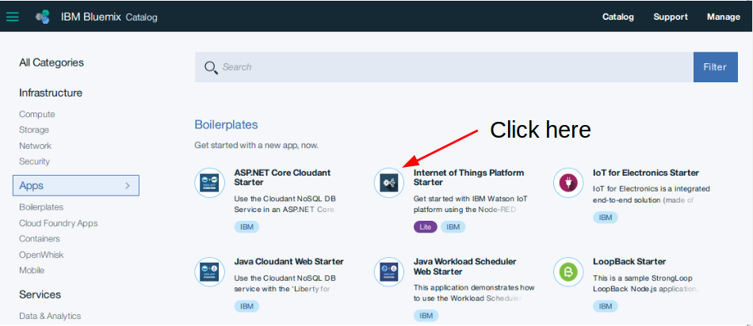

Step 9: Create a Cloud Foundry App
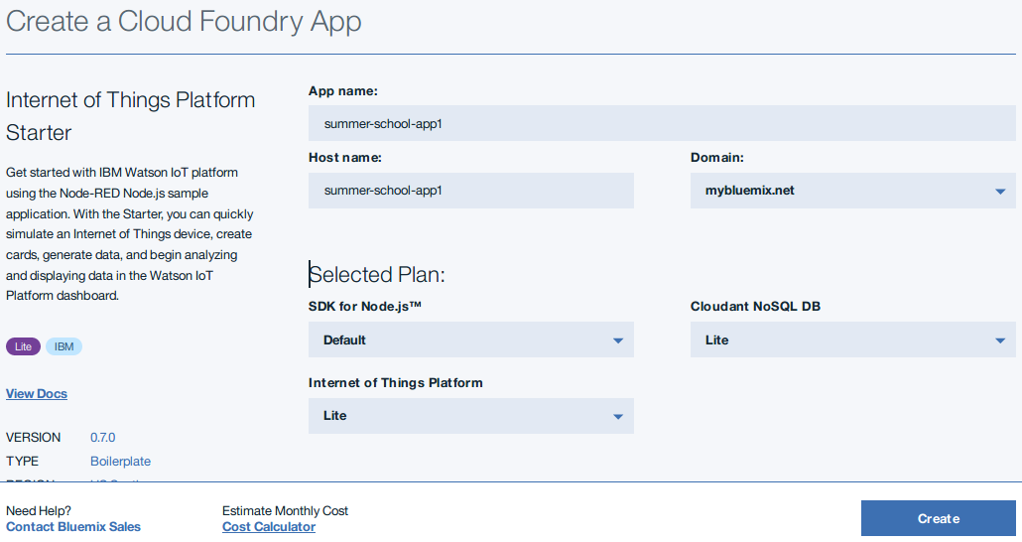

I am getting this error when I click Create?
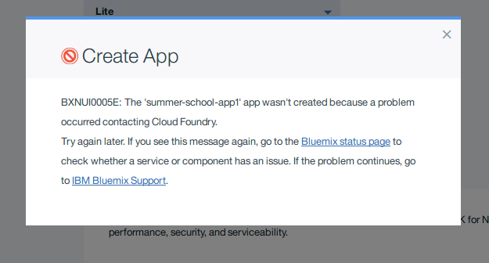

Try renaming the app and then restart the application. If the problem continues, please call for assistance.

Step 10: Wait for app to start running
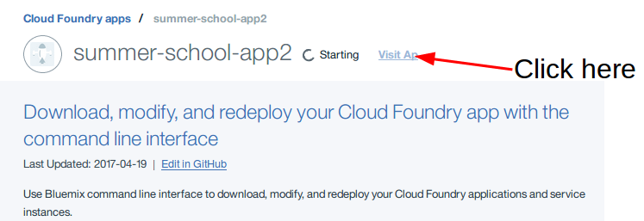

Step 11: Click on the URL once the app is running
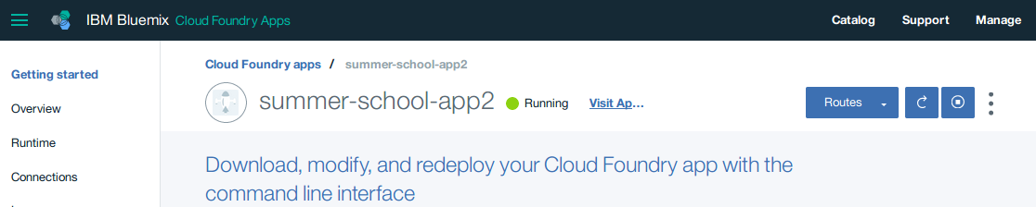

Step 12: Node-RED welcome message
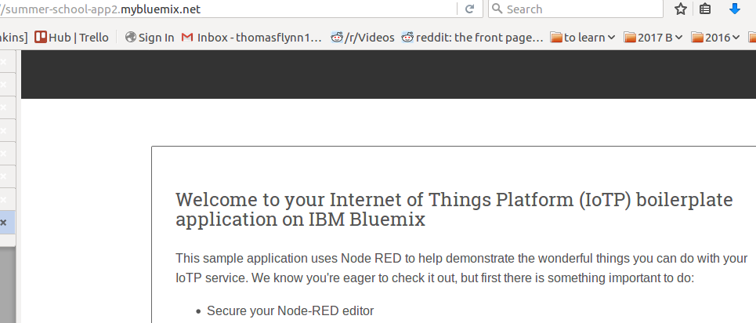

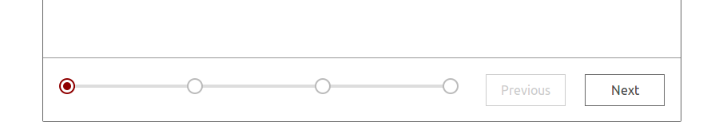
Step 13: Click next

Step 14: Secure your Node-RED editor
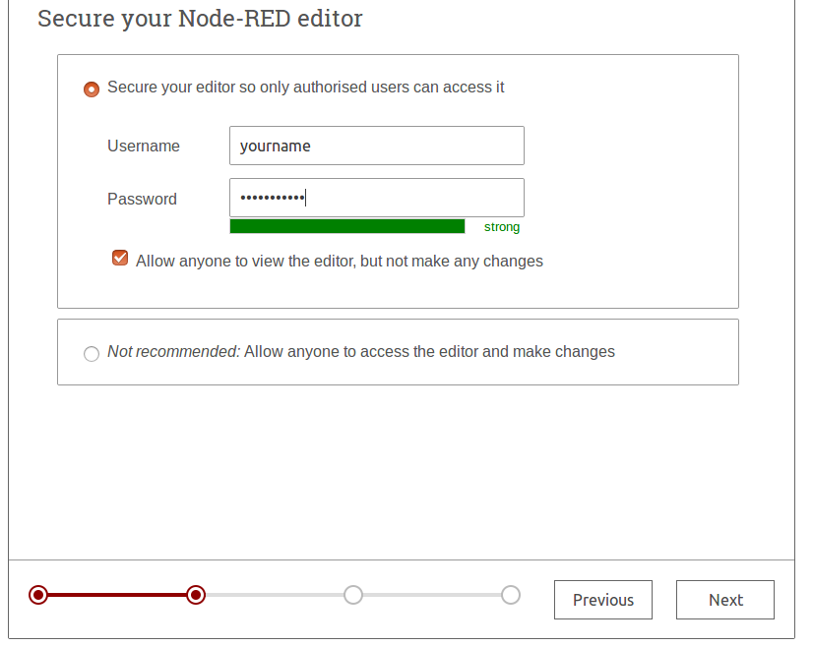

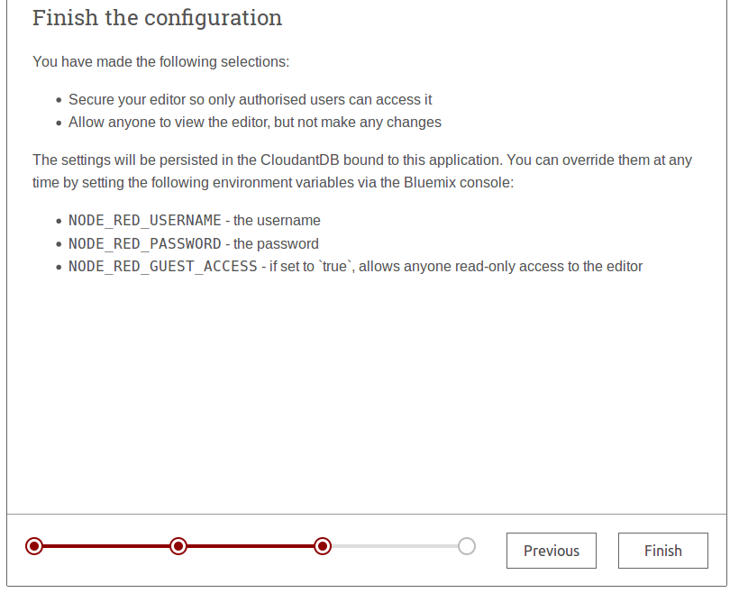
Step 15: Finish the configuration

Step 16: Click on “Go to your Node-RED flow editor”
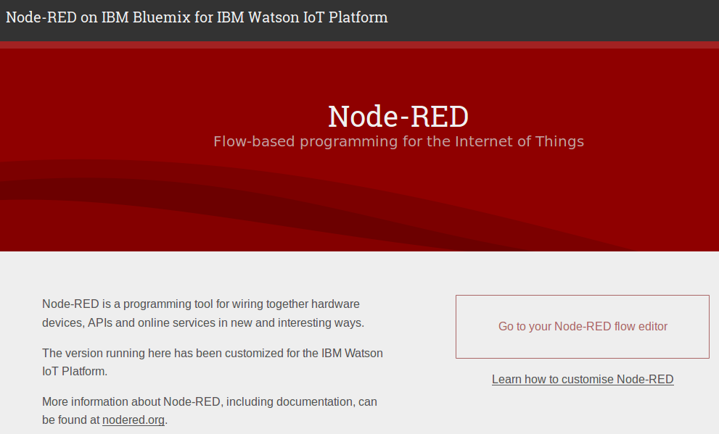

Step 17: Delete nodes in Flow 1
To delete nodes, drag the mouse over all the nodes in the flow. Then hit the delete key on the keyboard to delete them.
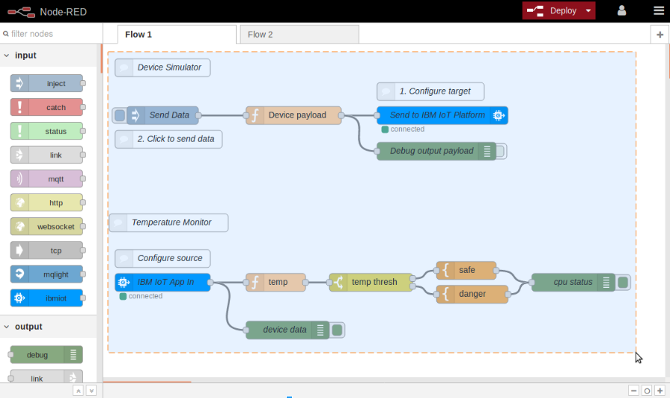

Step 18: Finished setup phase
Once you have reached this step raise your hand and inform the teaching assistant.
If the teaching assistant is occupied, continue onto part 2 of the lab.
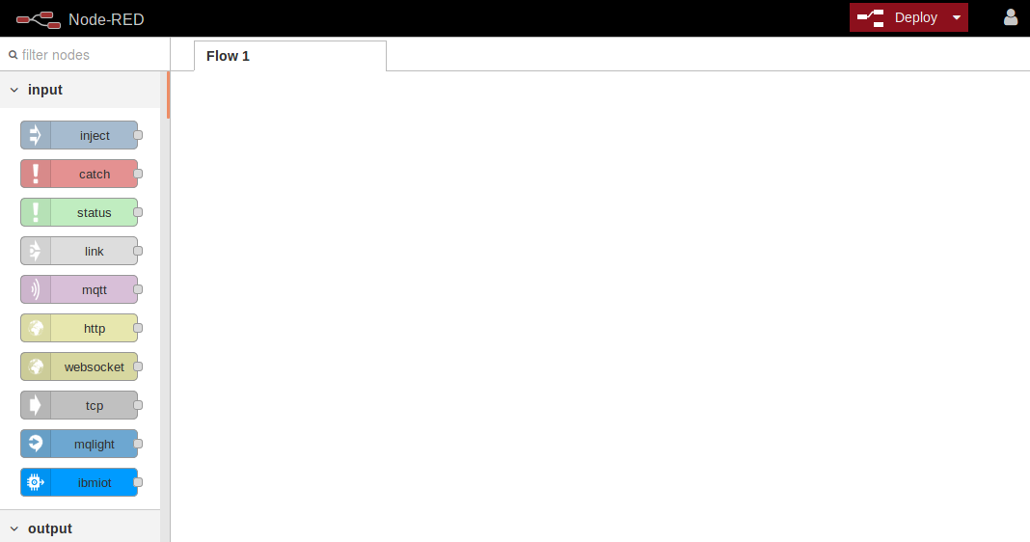

5 Node-RED Lab part 2

Step 1: Add inject node to Flow 1
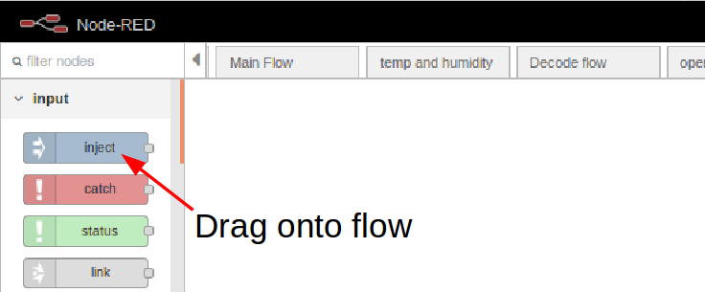

Step 3: Add function node to Flow 1
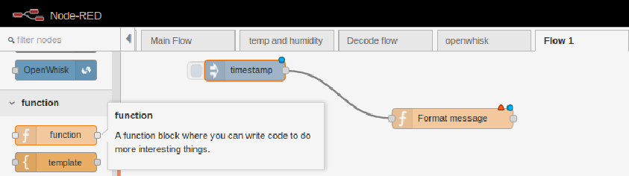

Connect the output of the inject node to the input of the function node as shown in the above figure.
Messages can be modified within the node by double clicking on the function node.
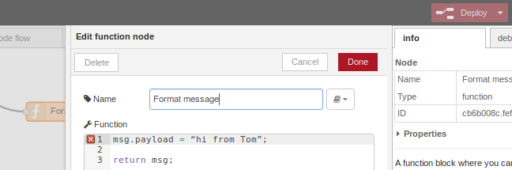

Add the following line but do not copy and paste as it may cause an error.
msg.payload = “hi from <insert your name>”;

Step 4: Add debug node to Flow 1
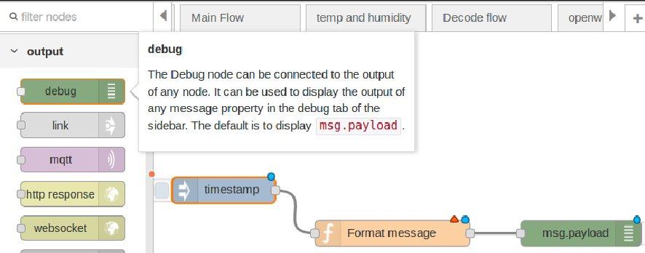

Step 5: Edit debug node
Change the output option to “complete msg object”.

Why do we need to see the complete message?
To help us understand the structure and attributes of messages as they pass through nodes.
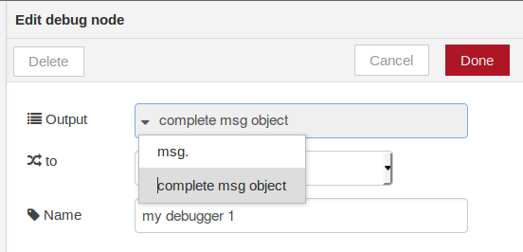

I cannot see my debug tab?
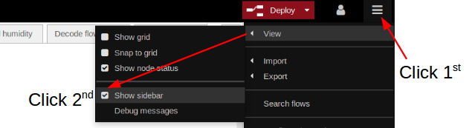

Step 6: Deploy Flow 1
After clicking on the drop-down arrow, click “Full”. Then click on the deploy button to deploy the flow.
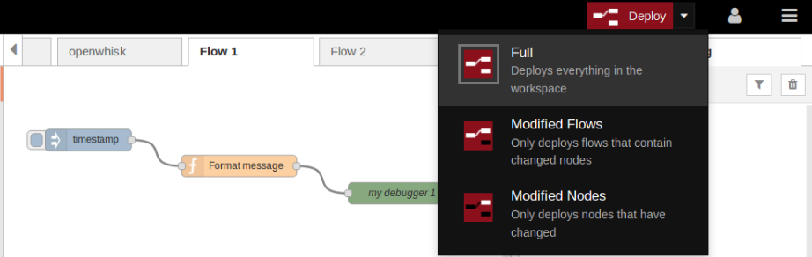

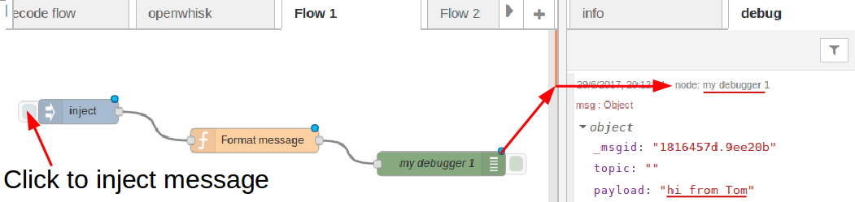
Step 7: Test debug node

In the debug tab on the right, notice how each new message has a uniquely generated msg._msgid
Notice that msg.topic is blank.
Notice the value of msg.payload is the value applied in the function node (“hi from <your name>”)

Step 8: Publish to the “iot-summer-school/group-<insert group number>” topic
Add the mqtt out node and wire it to the output of the function node
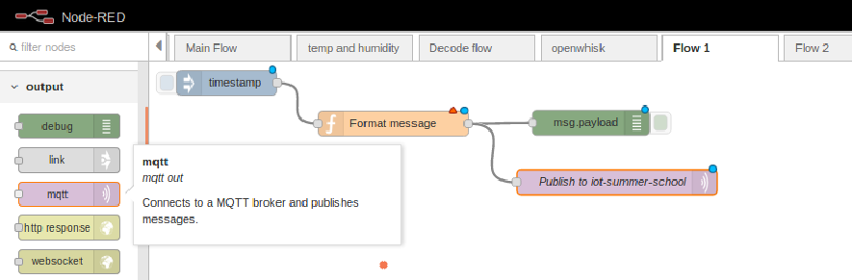

Double click on the mqtt output node and make the following changes.
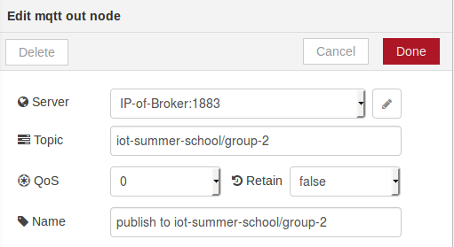

What is the mqtt out node going to do with the message?
The node will publish to the broker on “iot-summer-school/group-2” topic.
Any mqtt in node that is subscribed to that topic will receive a message with a payload containing
“hi from <insert your name>”

Will my flow also receive the message it just published?
No, we have only used an mqtt out node. This node only publishes messages and does not subscribe.

Step 9: Add subscribe node or “mqtt in” node
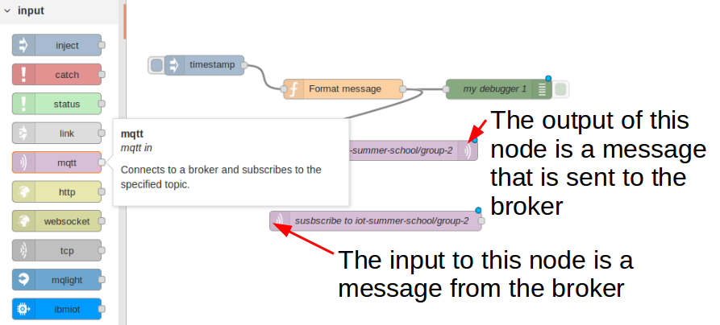

Step 10: Edit the mqtt in node
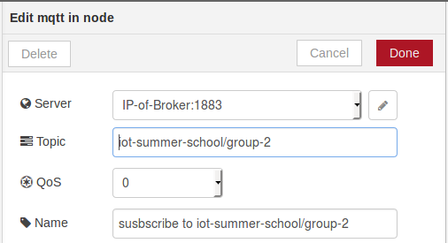

Step 11: Add another debug node
Make the same change as last time, we do this because we want to see all message attributes.
Then wire the output of the mqqt in node to the input of the new debug node.

Step 11: Deploy the application
Remember to hit the deploy button after making a change to a flow.

Step 12: Check the debug tab
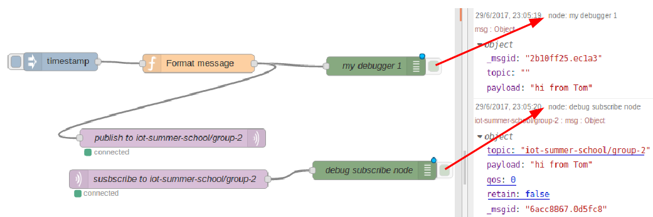
Notice the message captured in the “debug subscribe node” has the following attributes
topic: “iot-summer-school/group”
qos: 0
retain: false
And most importantly the payload contains “hi from <your name>”

Step 13: Help your group members
After you get the subscribe node working, go help group members that are having problems.
When everyone in the group can send and receive messages, continue to the next stage and create a new flow called “Flow 2”.
If you are struggling to keep up or having problems with your flow, do not worry.
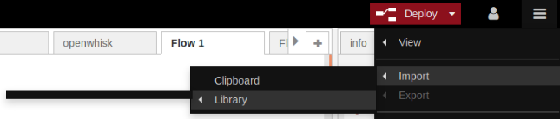
Everyone will be importing the part 1 solution provided below to use as the starting point for Flow 2.

Flow 2 Clipboard Starting point
[{"id":"31a61f50.5b8548","type":"tab","label":"Flow 2"},{"id":"1186df17.507979","type":"inject","z":"31a61f50.5b8548","name":"","topic":"","payload":"","payloadType":"date","repeat":"","crontab":"","once":false,"x":105.27777099609375,"y":136.30001831054688,"wires":[["cb6b008c.fef0e"]]},{"id":"cb6b008c.fef0e","type":"function","z":"31a61f50.5b8548","name":"Format message","func":"msg.payload = \"hi from John Doe\";\n\nreturn msg;","outputs":1,"noerr":0,"x":327.4721984863281,"y":139.17776489257812,"wires":[["8379426f.cbb51","b99ddb50.e3c97"]]},{"id":"8379426f.cbb51","type":"debug","z":"31a61f50.5b8548","name":"my debugger 1","active":true,"console":"false","complete":"true","x":613.7777099609375,"y":143.73880004882812,"wires":[]},{"id":"b99ddb50.e3c97","type":"mqtt out","z":"31a61f50.5b8548","name":"publish to iot-summer-school/group-2","topic":"iot-summer-school/group-2","qos":"0","retain":"false","broker":"de850a9d.6952c8","x":286.111083984375,"y":260.0000305175781,"wires":[]},{"id":"fa49e949.94837","type":"mqtt in","z":"31a61f50.5b8548","name":"susbscribe to iot-summer-school/group-2","topic":"iot-summer-school/group-2","qos":"0","broker":"de850a9d.6952c8","x":279.4444580078125,"y":326.6666259765625,"wires":[["97725758.16c928"]]},{"id":"97725758.16c928","type":"debug","z":"31a61f50.5b8548","name":"debug subscribe node","active":true,"console":"false","complete":"true","x":611.6666870117188,"y":312.22216796875,"wires":[]},{"id":"de850a9d.6952c8","type":"mqtt-broker","z":"","broker":"134.168.46.151","port":"1883","clientid":"","usetls":false,"compatmode":true,"keepalive":"60","cleansession":true,"willTopic":"","willQos":"0","willPayload":"","birthTopic":"","birthQos":"0","birthPayload":""}]

Node-RED lab part 2

Step 1: Importing Flow 2 starting point
Import the Flow provided above by copying it into your clipboard.

Step 2: Edit function node
Change from
msg.payload = “hi from <your name>”
to
msg.payload = "你好，世界";

You are now going to use the Watson language translate service to convert msg.payload from Chinese into english.

Step 3: Go to Cloud Foundry App control panel
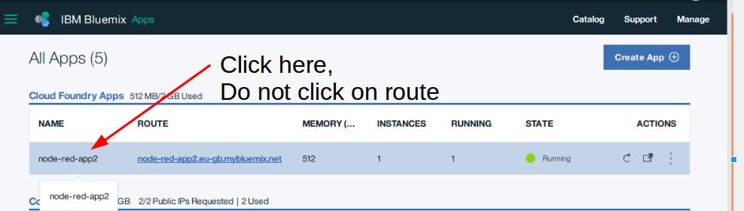
By clicking on route, you will be taken to another Node-RED flow editor screen.
However, we want to go to the Cloud Foundry App control panel instead.

Step 4: Click “Connect new” under Connections

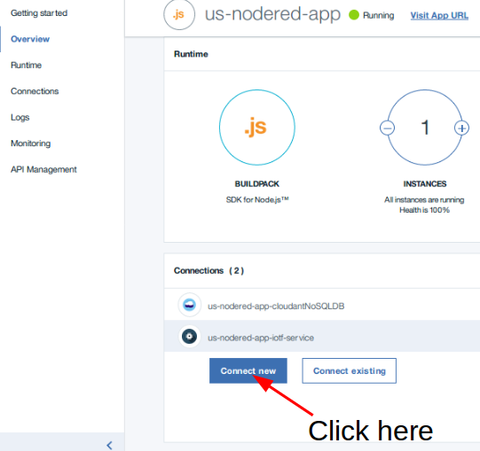

Step 5: Select Language Translator
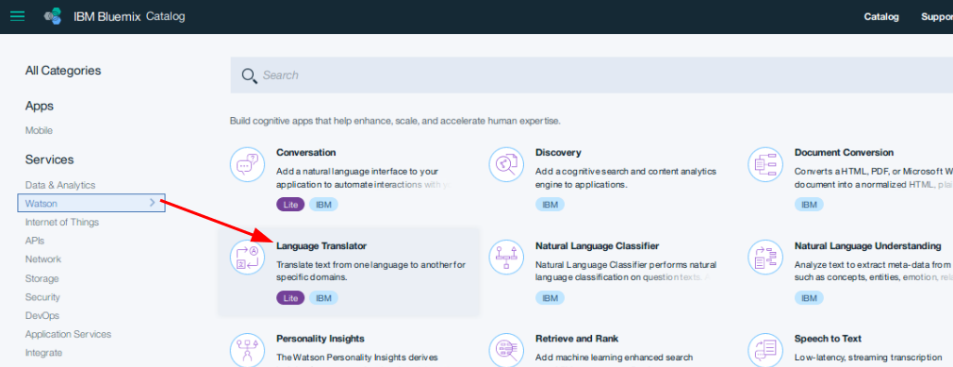

Step 6: Connect translator service to Cloud Foundry App
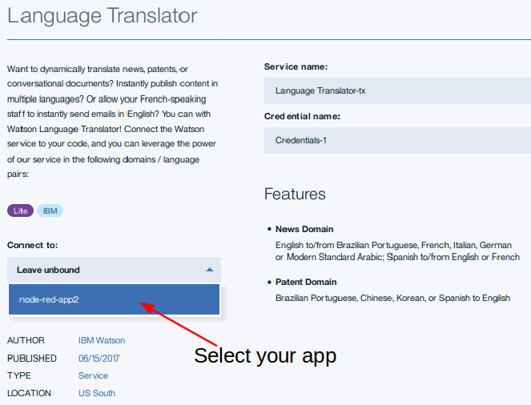

Step 7: Create translator service
In the bottom right hand side of the page. Click on “create” to create the service connected to your app.
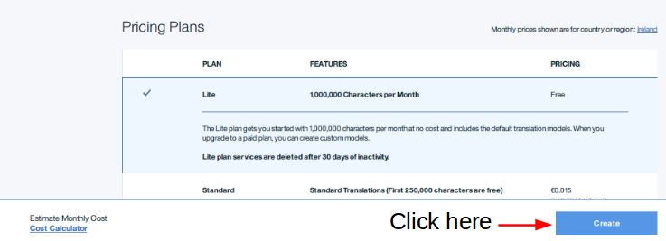

Step 8: Restart Cloud Foundry application
After creating a service you should get a prompt asking you to restart the application. Select yes.
Warning: If you do not restart your application after adding a service, you will not see the service in the list of available nodes in the Node-RED flow editor screen.

Step 9: Add Watson “language translator” node
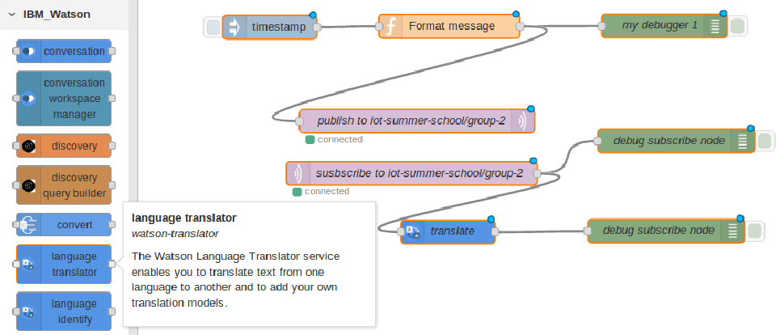

Add another debug node and wire it up to the output of the translate node (as shown in the above figure).

Step 10: Edit language translator node
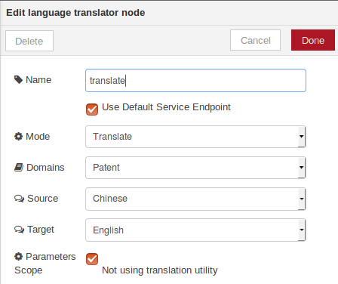

Step 11: Deploy and test translate using debugger node
Remember to hit the deploy button after making a change. You should see the message “Hello world” as the result of inputting “你好，世界” into the Watson translate service.
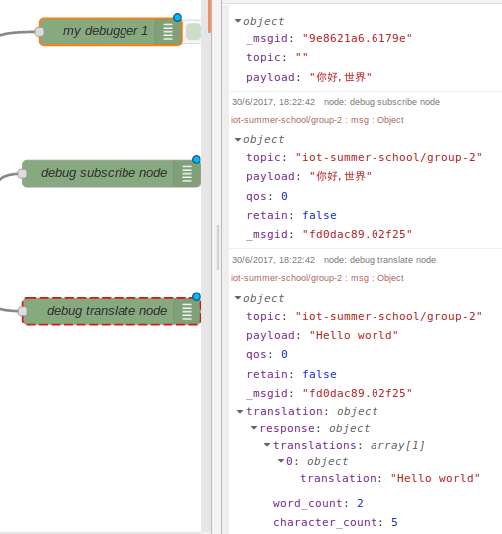

Step 12: Add Cloudant out node and connect to translate node
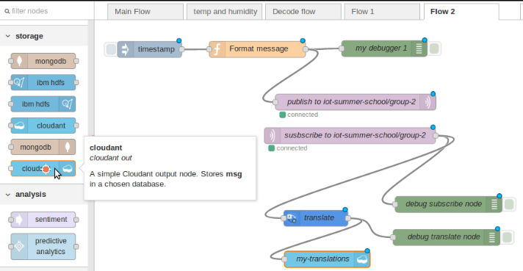

Step 13: Deploy and click the inject node
Click on the inject node to fire messages.

What is happening when I click inject now?
When you click on the inject node, a msg flows into the function node. In this node the msg.payload value is being changed. The modified message is then sent to an mqtt broker running on Bluemix.
An mqtt in node is subscribed to the topic “iot-summer-school/group<group number>”.
Now the message is flowing from the “mqtt in node” to both the “debug subscribe node” and the “translate” node.
After translating msg.payload from Chinese to english, the msg.payload is then stored in cloudant.

6 Finished
Congratulations, you have completed this lab.
In this lab you learned about:
-Creating your own flows
-Importing flows
-Mqtt pub/sub protocol
-Mqtt topic structure
-Adding services to Cloud Foundry Applications on Bluemix
-Analytic nodes such as language translate
-Cloudant nodes for storage

Answers
Can you visualize this flow?
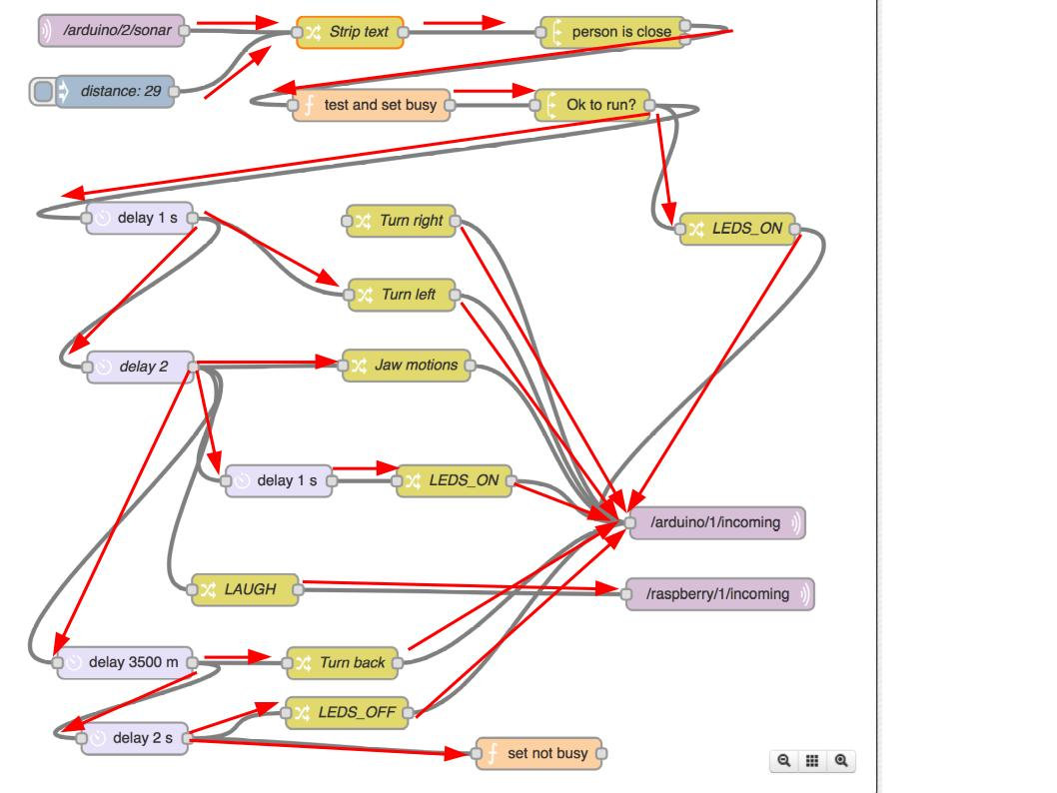

http://www.hivemq.com/blog/mqtt-essentials-part-6-mqtt-quality-of-service-levels

https://www.informatica.com/services-and-training/glossary-of-terms/extract-transform-load-definition.html

https://techcrunch.com/2010/09/03/cloudant/

